Experiment-6:

Observation of transfer characteristics of CMOS inverter.

Objective:

Showing the transfer characteristics of CMOS inverter with different ratios (**βp, βn)**.

Procedure:

1. At first creating a Schematic Diagram on DHCH2/3.
2. Then save this file as ‘.sch’ format from DHCH2/3.
3. Next in the ‘File’ option of DHCH2/3, choose ‘Make Verilog File’.
4. Next in Microwind2 ‘File’ option, choose ‘Select Foundry’ option and set the rule ‘CMOS 025.RUL’.
5. Finally in Microwind2 ‘Compile’ option, choose ‘Compile Verilog File’ option and run the ‘.txt’ file that previously saved from DHCH2/3.
6. To see the ‘Timing Diagram’ press ‘Run Simulation’ option on Microwind2.

Foundry Selection:

First after opening Microwind2 and by clicking ‘File’ Select ‘Foundry’ and CMOS025.RUL. This sets our layout editor designs of 0.25μ technology.

**β-Ratios:**

Ratio

NMOS

PMOS

|  |  |  |  |  |  |
| --- | --- | --- | --- | --- | --- |
| No | W | L | W | L | βp/βn |
| 1st | 50 | 1 | 5 | 1 | 0.1 |
| 2nd | 5 | 1 | 5 | 1 | 1 |
| 3rd | 5 | 1 | 50 | 1 | 10 |

Now, taking these values of L & W as other properties are constant of **β**

Ratios we will discuss the transfer characteristics. We will be the observations.

PMOS & NMOS Selection:

Taking 1st, PMOS ( W=50 & L=1) & NMOS { We will take ( 5 & L=1) } transistor and adding a source voltage (Vdd) and drain voltage (Vss). And adding a (Vdd) to change the well, we will continue adding 2nd & 3rd sets of transistor for POMS (W=5 & L=1) and NMOS (W=5 & L=1); PMOS (W=5 & L=1) and NMOS (W=50 & L=1) respectively.

Simulation:

We will simulation (voltage vs voltage) and then (input1, output1); (input2, output2) graphs will be shown if we select & click on more.

Schematic Diagram for CMOS:

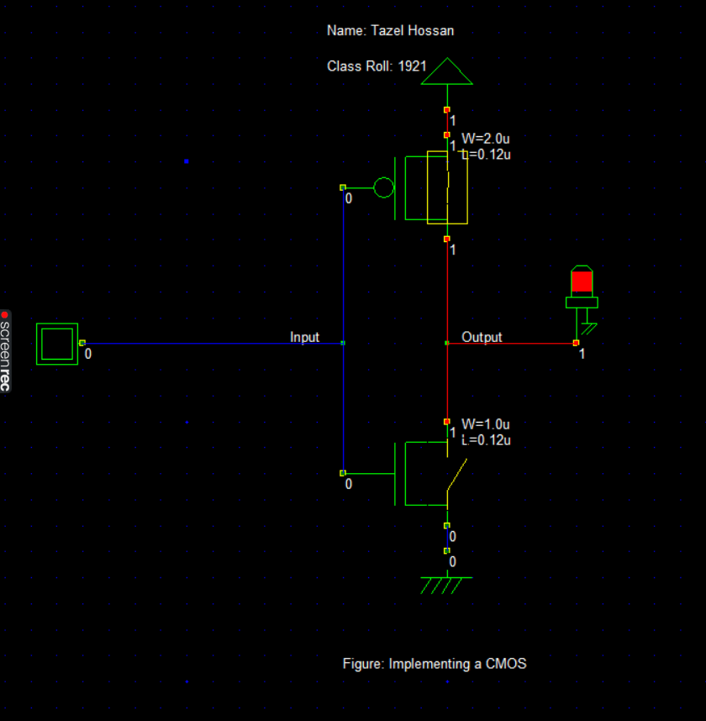

Timing Diagram on DSCH2/3:

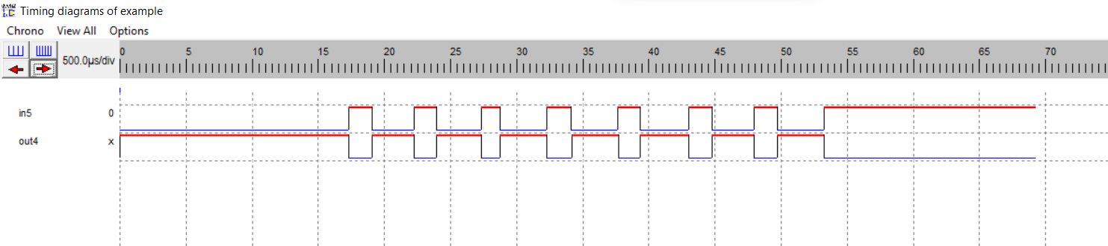

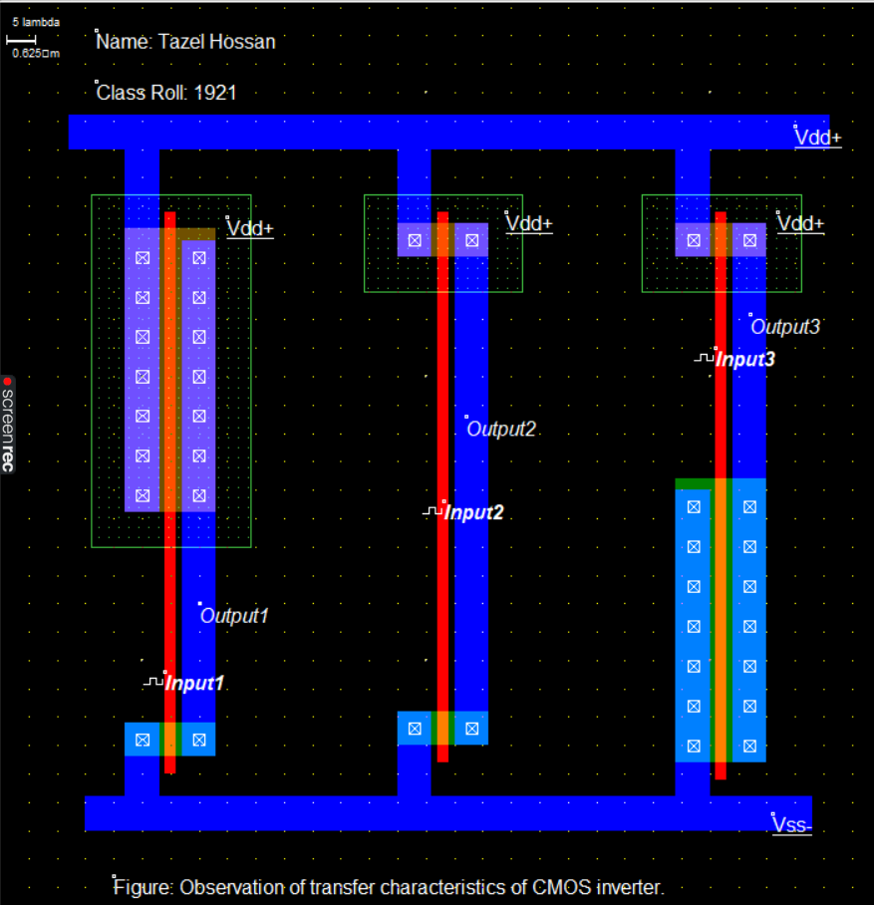Layout Diagram for CMOS:

Timing Diagram on Microwind:

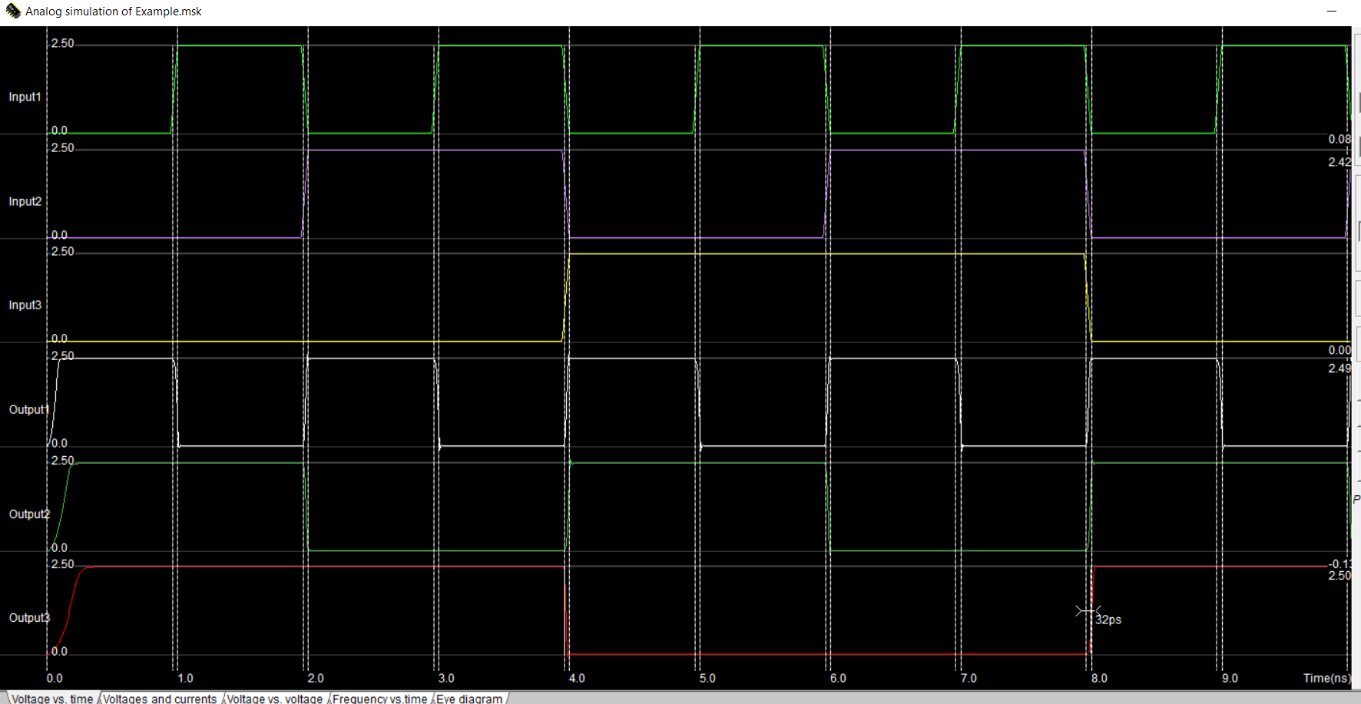

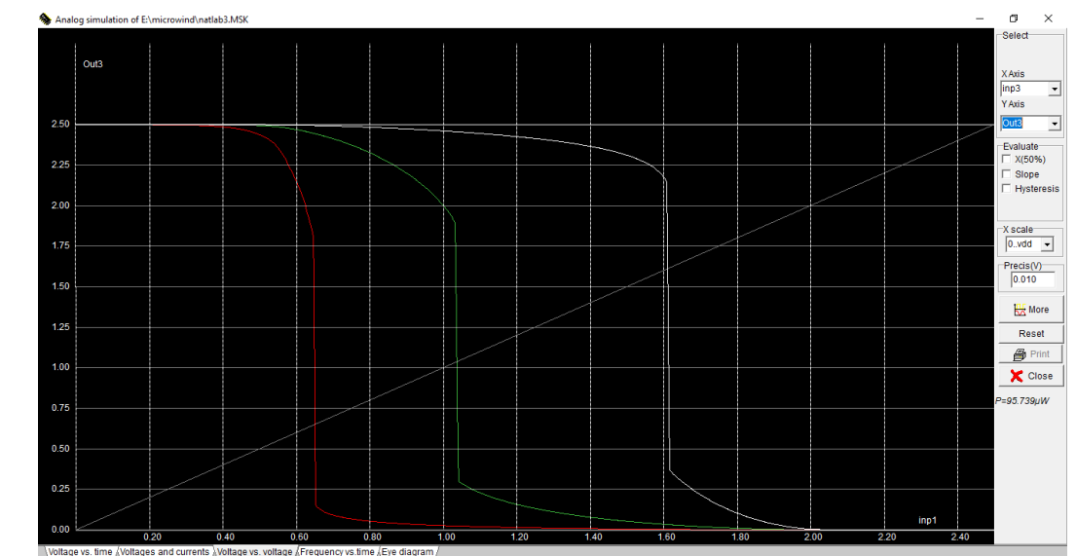(Voltage vs Voltage) Characteristics Diagram on DSCH2/3:

Result:

We observed that increasing the value of β ratio will have impact on the curves, it will slightly move towards the origin (0).